Evergreen Fleet Motorpool Policy & Operations Manual for Driving Agency/State-Owned Vehicles
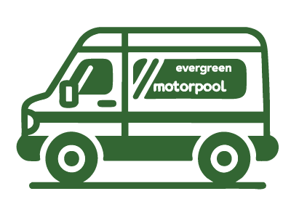
This document will advise you on current Evergreen and Enterprise-Wide Transportation policies, procedures, and safe operations of Evergreen and state-owned vehicles.
Contents
Who Can Become a Driver 2
Criteria for Restricting a Driver from Driving a State Vehicle 2
Driver Responsibility 2
Evergreen Fleet Motorpool Locations 4
State DES Fleet Motorpool Locations 5
Vehicle Types 6
E-Plates and M-Plates 7
Reserving a Vehicle 8
Vehicle Pickup/Checkout 8
Cancellations & No-Shows 9
Fueling Your Vehicle 9
Charging Your M-Plated Electric Vehicle 10
Large 12-Passenger Full Size Vans 11
Operating the Wheelchair Lift Van 13
Roadside Assistance 14
If You Are Involved in An Accident 15
Returning Your Vehicle 16
Valid License to Drive and Driving Experience Statement 18
Full Size Van Safe Driving Practices 18
Policy Acknowledgement and Acceptance 19

Who Can Become a Driver
Drivers refers to staff, faculty, and students operating a college or state-owned vehicle under the direction of the college.
Eligibility:
- Possession of a current driver’s license that is valid under WA state law.
- Minimum of 2 years of driving experience and resulting in being at least 18 years old.
- Agree to advise supervisor/faculty member by the next business day if their legal status to drive changes.
- Driving record is free of violations that restricts vehicle driving assignments.
- Agreement to review and follow the Evergreen Motorpool Policy and Travel Policy.
- Review the Washington State Department of Enterprise Services Enterprise-Wide Transportation Policy and associated documents that pertain to the authorized, safe, and efficient operations of vehicles used on state business and to follow applicable policies and procedures, including use of vehicles for official state business only. Comply with Enterprise-Wide Transportation Policy Procedure 3, Van Management.

Criteria for Restricting a Driver from Driving a State Vehicle
Within the past two years, any suspension/revocation of license for reckless driving, hit and run, leaving an accident scene, failure to appear, DUI, or other vehicle related felony; or for multiple traffic offenses,
Two moving violations/infractions in 12 months or
Three moving violations/infractions in 24 months
Resulting in a Conditional Status driving record or subsequent suspension/revocation of license.
You must attest that you meet the eligibility requirements and that your driving record is free from the above excluding driving criteria for driving a state-owned vehicle.

Driver Responsibility
DO:
- Use vehicles for official purposes only.
- Restrict passengers to college employees and Evergreen students or invited keynote speakers/guest lecturers.
- Carry your driver’s license.
- Use Seat Belts – Check before you begin driving.
- Ensure passengers are using seat belts.
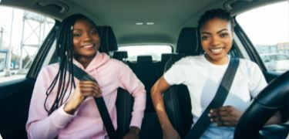
- Lock the vehicle when not in use.
- Obey all traffic laws, including posted speed limits.
- Always use vehicle’s headlights.
- Adjust driving speed and vehicle equipment (use of headlights, etc.) to changing weather conditions. Additionally, the driver should alter travel plans as needed for personal and occupant safety due to inclement weather.
- Avoid distractions while driving.
- Report vehicle damage/accidents immediately.
- Become personally responsible for and promptly pay to the appropriate jurisdiction parking tickets, citations or infractions received while operating a state vehicle. Payment of fines and citations under these circumstances is the sole obligation and responsibility of the driver and will NOT be reimbursed or paid by the State.
- Report odometer readings correctly upon vehicle return. If you are a staff person assigned a state vehicle, you are required to report monthly your vehicle’s odometer reading to Evergreen Fleet Motorpool by the 25th of each month.
DO NOT:
- Drive under the influence
- Use or allow use of tobacco products, smoking, or vaping in vehicle.
- Transport alcohol, cannabis products, or any other intoxicating substances, firearms, weapons, or explosives in state vehicles.
- Use ear buds/phones. These are a distraction and create an inability to hear emergency warnings.
- Drive dangerously, aggressively, or speed.
- Use vehicle for personal business or errands.
  - Drivers engaging in unauthorized use of the vehicle are not covered by the state’s insurance and will be held personally responsible during an accident or other claim.
- Transport passengers who are not on official state business.
- Use vehicle to commute back and forth from home.
- Hold your cell phone while operating the vehicle.
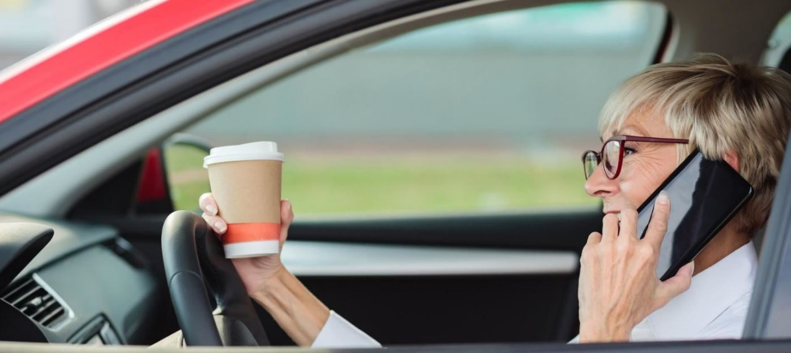
Your actions may make you negligent if involved in an accident, and the state may determine your negligence puts you at fault and personally liable for damages to people and other vehicles/buildings.

Evergreen Fleet Motorpool Locations
- Evergreen Motorpool/Parking Office: Communications Building, Room 105. Open M-F 9am-4pm.
- Evergreen Motorpool Vehicle Pickup/Return: Vehicle key pickup and return is now conducted via a 24/7 automated key box system that is located under the overhang of the Arts Annex Building. You will use your Evergreen Agile Fleet login (evergreen email address) and your Evergreen Agile Fleet password to login to the key box system to obtain and return your keys. You will need the login credentials to obtain and return keys. Vehicles are in Lot B in the marked Fleet Motorpool stalls. The vehicles should be returned to Lot B as well. Keys need to be returned to the automated key box system. Your reservation remains active until the keys are properly returned to the automated key box system.
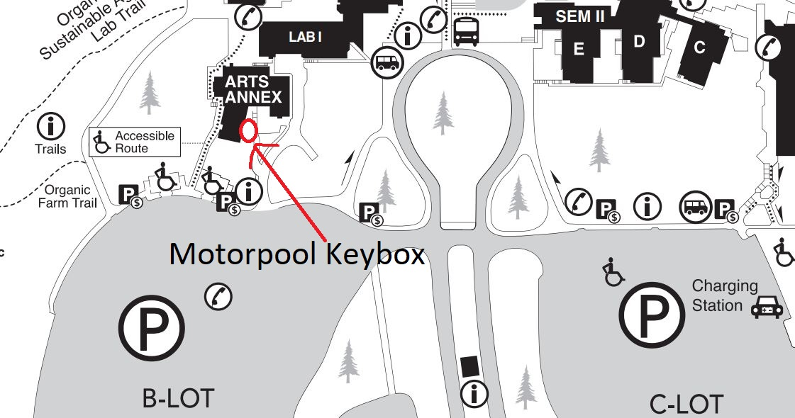

- If you are driving a college department assigned vehicle (shops, lab/farm), the vehicle storage and key location will vary. Ask your supervisor/faculty for information.

State DES Fleet Motorpool Locations
- DES Tumwater Vans: 7510 New Market Street SW, Tumwater, WA 98501
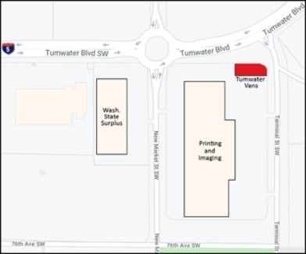
This location uses an automated self-service key box which is located in the parking lot across from the row of vans. Available 24-7.
- DES Capitol Campus Plaza Garage: 1129 Washington Street SE, Olympia, WA 98501
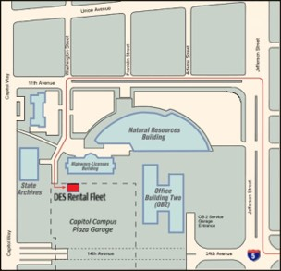
This location uses an automated self-service key box which is located on the left as you enter the garage. The vehicles are stored in Rows D5 and D6. Available 24-7.

- DES Fones Road: 1312 Fones Rd SE, Olympia, WA 98501
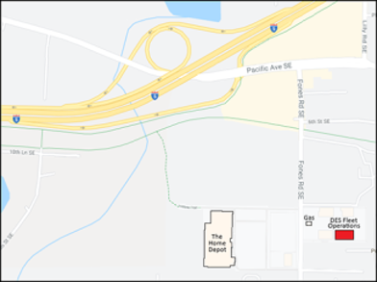
Open 7:30am to 4:30pm M-F, except for holidays. Key pickup must be completed in this period. Returns can be completed 24-7. Enter the office to pick up keys. Vehicles scheduled for return after 4:30pm on Fridays will be charged for rental days over the weekend.

Vehicle Types
You can rent different vehicle types from either the Evergreen Fleet Motorpool or via the DES Fleet Motorpool locations.
Vehicle Types from Evergreen (E-Plate & M-Plate Vehicles):
- 12-Person Van
- Wheelchair Lift Van – Varied Seating Capacity (2-9 passengers) depending on number of wheelchairs used.
- 8-Person Van
Vehicle Types from DES Tumwater Vans (M-Plate Vehicles):
- 12-Person Van
- 8-Person Van
- Electric Cargo Van – Full Size (E-Transit–100 Mile Range)
- Cargo Van – Full Size (Econoline)
- Cargo Van - Small (Transit-Connect)
Vehicle Types from DES Capitol Campus Plaza Garage (M-Plate Vehicles):
- Electric Sedan (Chevy Bolt)
- Electric SUV (Mach-e, ID4, etc.)
- Hybrid Sedan (Prius, Sonata, etc.)
- SUV – Standard (Escape, RAV4)
- Full Size Truck (Silverado)
- 7-Passenger Minivan (Pacifica)
Vehicle Types from DES Fones Road (M-Plate Vehicles):
- Electric Sedan (Chevy Bolt)
- Electric SUV (Mach-e, ID.4)
- Hybrid Sedan (Prius, Sonata, etc.)
- 7-passenger minivan (Chrysler Pacifica - PHEV)
- Wheelchair ADA Mini-Transit Van
- Other Vehicle Types are limited such as full-size trucks, standard sedans and SUV’s, etc.

E-Plates and M-Plates
A vehicle’s license plate type is important to know when you operate the vehicle as it identifies the agency that owns the vehicle (Evergreen or WA State DES Fleet). Procedures are slightly different depending on the E or M plate designation, especially during accident claims.
- E-Plated Vehicles:
  - The exempt license plate will end with an “E.”
  - These vehicles are owned by Evergreen and are in the Evergreen Fleet Motorpool
- M-Plated Vehicles:
  - The exempt license plate will end with a “M.”
  - WA State DES own these vehicles.
  - Some DES M-Plated vehicles are located on Evergreen campus and within the Evergreen Fleet Motorpool (i.e., Mercedes Sprinter Vans) while the majority come from the DES Fleet Motorpool locations.
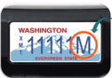

Reserving a Vehicle
Reservation request for vehicles from the Evergreen Fleet Motorpool location or any of the DES Fleet Locations can be made by visiting the Evergreen Fleet Motorpool Agile Fleet Reservation system and clicking on “Make Reservation.”
https://evergreen.agilefleet.com
Per College Motorpool Policy: Evergreen Fleet Motorpool Staff are the only authorized agents to make reservations for DES State Fleet Vehicles on behalf of our agency. Thus, evergreen staff/faculty MAY NOT make DES vehicle reservations directly. Only Faculty/Staff may make reservation requests for vehicles. Students should have their faculty or club advisor make the reservation. An accurate Budgetary Fund and Org number is required to complete your reservation request.
An approved Travel Authority is required BEFORE checking out the vehicle.
Contact the Parking/Motorpool Office if you need assistance in placing your vehicle reservation request.

Vehicle Pickup/Checkout
Your vehicle pickup location and procedures will vary based on the location selected when reserving the vehicle. Check your reservation confirmation email for location.
Pickup from Evergreen Fleet Motorpool
- Key Pickup: Automated Key Box system is available 24/7 and is located at the Arts Annex overhang. You can pickup the keys 15 minutes before reservation start and up to two hours after reservation start time. After 2 hours, the reservation is cancelled, and a no-show fee is assessed. You will need your Evergreen Agile Fleet login credentials to pickup AND return the keys.
- Vehicle Pickup: Vehicles are parked in Lot B in the marked Fleet Motorpool Stalls.
- Your key ring will indicate which vehicle you will be driving. Match the license plate number from keys to vehicle.
Pickup from DES Tumwater Vans or Capitol Campus Plaza Garage
- These locations use a self-service automated key and vehicle assignment system. You must pick up the keys within 15 minutes before start time and up 2 hours of the reservation start time, or the reservation will be auto-cancelled and you will not be able to obtain your keys.
- At the automated key box location, click the "Check Out Vehicle Button" and use your college email address and DES Fleet Commander password to login to the key box. (You must be an authorized DES Driver and have ALREADY setup your DES Fleet Commander password to gain access to the key box).
- Click the confirmation # that Evergreen Motorpool forwarded you for the vehicle reservation confirmation. If you do not see your reservation/vehicle listed, click the "Check Out via Confirmation Number" button. Enter the 6-digit confirmation number using the keypad. The confirmation number was emailed to you by Evergreen Motorpool. Follow the remaining on-screen prompts.
- If you are leaving a personal vehicle, please select YES on the PV question, and enter your personal vehicle's license plate number.
- The key box will identify which vehicle you are assigned and will release the keys and fuel cards.
- Park your personal vehicle in the rental vehicle area.
Pickup from DES Fones Road Location
- Open 7:30am-4:30pm, M-F, closed holidays.
- Pickup keys within the office during business hours. Must show your current driver’s license for proper identification.
- Ask the office staff where to park your personal vehicle.

Cancellations & No-Shows
You must cancel your reservation within the Evergreen Agile reservation system (evergreen.agilefleet.com). Once logged in, click on My Schedule from the left-hand navigation system. Find the reservation(s) needing to be canceled and click on the cancel button and complete the steps and submit.
Failure to cancel the reservation before 48 hours of your reservation start time will result in a $35 cancellation fee being charged to your budget. Likewise, if you have multiple vehicles reserved for your trip and determine you need fewer vehicles, you must also login 48 hours before the reservation start time to make the adjustments, otherwise your budget will be assessed a $35 late cancellation fee.
If you fail to cancel the vehicle requests AND do not checkout the vehicle within the reservation pickup timeframe, your budget will be assessed a No-Show fee equivalent to the full daily rental rate of the vehicle.

Fueling Your Vehicle
WEX Fuel Cards are used to pay for gasoline for both E-Plated and M-Plated vehicles at off-campus fuel pumps. WEX Fuel Cards are accepted at most major fuel stations (Shell, Texaco, Chevron, etc.). Look for the WEX Fleet card symbol on the pump for verification.
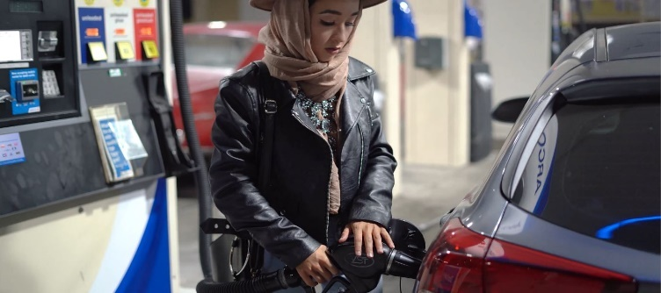
The Driver or Operator ID PIN # required to enter at the off-campus fuel pump will be the last 6 digits of your Evergreen A#.
1.Insert the WEX Fuel Card at the pump
This is a vehicle specific card and should only be used for the assigned vehicle.
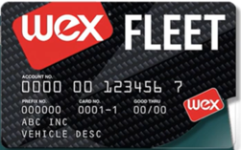
2.Enter the Driver/Operator ID PIN
  - This is the last 6 digits of your Evergreen A#. For example, A00123456 would have an ID Pin of 123456.
3.Enter Odometer Reading
  - Check the odometer and ensure it is the current mileage reading.
4.Begin Fueling
DO NOT use the WEX card assigned to one vehicle to fuel a different vehicle on the trip. You will be personally and financially responsible for any purchases that are in violation.
- *If driving a college department assigned vehicle (shops, lab/farm) ask your supervisor/faculty for information on how/where to fuel the vehicle.
- *If driving an M-Plated vehicle, and the card is declined, you can contact DES Fleet Operations for assistance in real-time. Should that decline, you can pay with your personal card and be reimbursed. A receipt will be required for reimbursement.

Charging Your M-Plated Electric Vehicle
M-Plated Electric Vehicles come with a WEX EV Fleet Card as well as a WEX Fleet Mastercard.
The Wex EV Fleet Card can be used at the following charger networks:
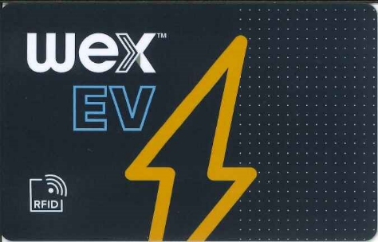
AmpUp, Blink, Chargepoint, EVConnect, EVGateway, EVGo, Flo, and Noodoe
The Wex Fleet Mastercard will work at any EV Charger that accepts open-loop payments (i.e., Electrify America). This card can also be used for roadside assistance during your trip.
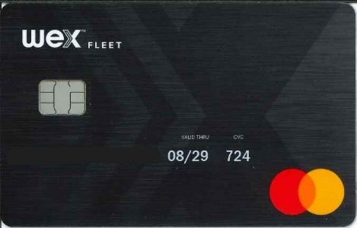
Find charging stations by visiting www.plugshare.com and filtering by network to show the appropriate stations.
Plug-in the vehicle to the charging station and tap the RFID card by the reader. Watch for prompts on the charging display. If leaving the vehicle while charging, lock the vehicle. Unplug the charger when charging completed.
If you are planning a trip exceeding one hundred miles, it is advised to plan your commute trip time and route BEFORE leaving to allow for charging, if needed.

Large 12-Passenger Full Size Vans
The increased height, length and weight of large cargo and passenger vans affect their handling characteristics. Vans handle differently than sedans even when performing routine vehicle maneuvers and require special handling knowledge for safe operation of the vehicle.
Van drivers are responsible for and must insist all occupants wear safety belts at all times. Visually check use and during transit, stop and legally park the van if made aware of passenger safety belt non-use.
Center of Gravity in Large Vans
- Much higher than sedans due to size and shape of the van.
- Center of gravity rises when adding cargo and passenger weight.
- When filled to capacity, it can be as high as the steering wheel.
- A higher center of gravity impacts the vehicle stability increasing the likelihood of rollover.
  - Compromises the stability of the van, especially during quick maneuvers such as:
    - Sudden turns
    - Striking a curb at higher speeds
    - Running off the pavement
    - Trying to bring wheels back to surface too quickly during corrections.
- Stopping and Following Distance requirements are longer in vans. Increase the distance between vehicles. Vans will require longer braking distances so begin applying brakes sooner. This is an especially crucial factor in rain, fog, or other difficult driving situations caused by weather conditions.
- Changing Lanes
  - Create more space by reducing speed.
  - Use mirrors and watch for blind spot activations if the vehicle is equipped.
  - Activate turn signals early.
  - Ask for assistance from your passengers to locate other vehicles around you.
- Turning
  - Reduce your speed.
  - For left turns, start your turn farther forward.
  - For right turns, pull up/out and start your turn as far into the intersection as possible.
  - Taking your turns too quickly or too early in a large van can cause the side panels of the van to scrape objects and other vehicles located on the corner.
- Curves
  - Taking curves too fast will cause a significant shift of weight causing the van to lean in the opposite direction of the curve. As the weight of the van shifts in response to the curve, the tires will come off the roadway and flip the vehicle on its side. Slow down on curves!
Backing up and Parking
- Avoid parking where you need to back out of a spot.
- Use your passengers as spotters as needed.
- On a hill, turn the wheels towards the curb so the van will roll against the curb and set the parking brake.
- DO NOT bring the large vans (Cargo, 8-Passenger, 12-Passenger) into parking garages.
  - Garages have low height restrictions and tight turning circles. You may damage fire suppression systems hanging from the overhead ceilings.
  - Confined spaces lead to increased risk of vehicle damages on side/top panels, fenders, bumpers, and property damage.
Loading Passengers and Cargo
- Park vans out of traffic or travel lane.
- Turn on hazard flashers when actively loading.
- Turn off ignition when not in the driver seat.
- Adjust mirrors as needed.
- Ensure cargo is secured and passengers are wearing seat belts before pulling forward. Ensure passengers are cleared of van when unloading and before pulling forward.
A primary contributor to any vehicle rollover is a loss of control caused by tire failure.
Tire failure causes vehicle weight to shift and become unbalanced. Due to the higher center of gravity in large vans, they are particularly susceptible to rollover from a tire failure.
If the tire pressure monitoring system activates, stop and inspect tires for flats/leaks. If possible, find a location to check air pressures with a gauge and inflate to proper PSI levels.
- If a tire fails:
- Ease gently off the gas.
- Keep a firm grip on the steering wheel.
- While gently easing into the brakes, keep the vehicle pointed straight ahead and gradually reduce speed.
- Pull off the road without making any radical steering inputs.
- DO NOT HIT THE BRAKES HARD
- DO NOT MOVE THE STEERING WHEEL ABRUPTLY
- Once safely pulled over, call Fleet Roadside Service for assistance.

Operating the Wheelchair Lift Van
If you are transporting an individual using a wheelchair and driving Evergreen Fleet’s Wheelchair Lift Van, it is critical that you know how to safely operate the vehicle and its wheelchair lift.
Please watch the below videos to learn how to safely operate the lift as well as secure the wheelchair to the chair restraint system inside the vehicle.
How to use the BraunAbility Wheelchair Lift (YouTube Video)
How to Stow and Open the Go-ES Foldaway Seats (YouTube Video) - To make space for the wheelchair and find the wheelchair securement systems stowed under these seats.
Once you have watched the above video, please watch the below two short videos. It is ESPECIALLY important that you know and understand how to properly secure the wheelchair AND the wheelchair occupant using the securement systems. Wheelchairs MUST be forward facing when secured in the vehicle.
Wheelchair Securement - Quick Demo Video
Wheelchair Occupant Securement - Quick Demo Video
Proper Wheelchair Restraint Locations

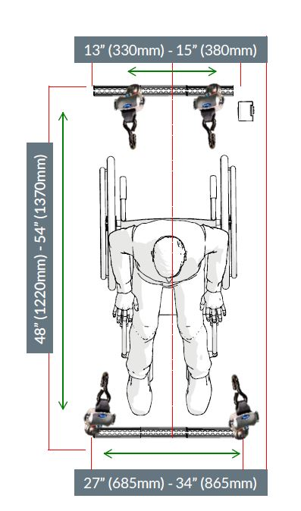

Roadside Assistance
Roadside assistance is available 24 hours via our contracted Fleet Roadside Service. The number will be in the key packet or glove box packet inside the vehicle.
Use the WEX Fleet Fuel card to pay for the Fleet Roadside Services.
Services Include:
- Winching / Towing
- Jump Starts
- Lock out service
- Spare tire change
- Fuel delivery
- Mechanical Breakdowns
Be prepared with the following information:
- Driver/Operator PIN Number (same as the fuel pin – Remember, this is the last 6 digits of your Evergreen A#).
- Fuel Card number and expiration date.
- Vehicle Description and Exact Location.
- Phone number to call you back.
- Your budget will be charged for non-mechanical service calls.
If the vehicle needs towed by the Roadside Assistance Vendor:
- In Thurston County: Tow the vehicle to the DES Fleet Location on Fones Road located at 1312 Fones Road, Bldg 4, Olympia, WA 98501.
- Outside of Thurston County: Tow the vehicle to the nearest dealership of the vehicle make or closest repair shop. Call Evergreen Fleet Motorpool to inform us of the towing incident. If after hours, leave a message with the vehicle plate #, reason for towing, and location it was towed, and your contact information if calling after hours.

If You Are Involved in An Accident
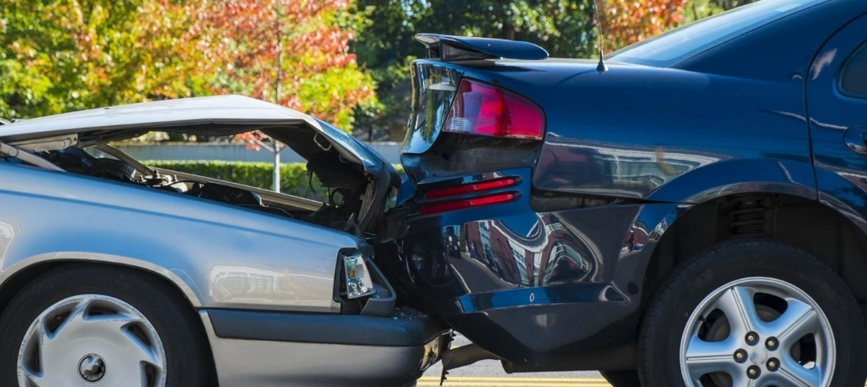
Keep calm!
  - If vehicle is drivable, pull to the side of the road and out of traffic.
  - Stop. Do not leave the accident scene until released by law enforcement.
  - Make sure you are ok, check for damages and personal injury.
- Report the collision.
  - Call 911 and cooperate with their investigation.
  - Provide factual and accurate information. The vehicle registration and state insurance information are in the vehicle packet.
  - Do not offer your opinion of who is at fault. Only discuss your actions with law enforcement and do not admit fault or make statements about how the college or state will respond to the collision, financial or otherwise.
- Complete the vehicle accident form S.F.137 located in the vehicle packet found in the glove box.
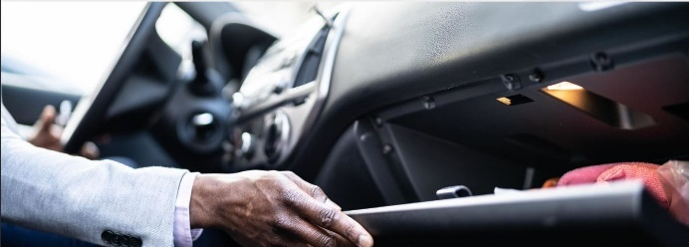
- Share information.
  - Exchange information with the other driver(s)
  - Name, insurance, work contact info, vehicle information, etc.,
  - Get contact information from any witnesses including their names, addresses, and phone numbers.
  - For insurance claims provide State of Washington liability insurance card for Tort Claims. This is in the vehicle packet. Claimants can call DES Risk Management at 360-407-9199.
  - Take pictures of the scene and vehicle information if safe to do so.
- If in an M-Plated vehicle, complete the CEI Accident form from the vehicle packet/glovebox BEFORE leaving the scene.
  - Call and report the accident to CEI at 877-443-5777, option 4.
  - CEI can coordinate towing service if the vehicle is not drivable from the accident scene.
- If in an E-Plated Vehicle, contact Evergreen Motorpool and/or Evergreen Police Services if after business hours.
- If vehicle is safe and legal to drive, finish your trip.
  - Contact Evergreen Motorpool ASAP to share the information.
  - If it is a M-Plated Vehicle, contact DES Fleet Operations at 800-542-6840.
- If not drivable, CEI should have arranged a tow service if in an M-Plated Vehicle.
  - Contact 800-542-6840 and include name, agency (Evergreen State College), vehicle license plate, and where the vehicle was towed.
  - Contact Evergreen Motorpool. Share the above information.
  - If CEI did not arrange tow service or you are in an E-Plated Vehicle, call Fleet Roadside Assistance for towing and use the WEX Fuel Card to pay for the service.
- Drivers have potential liability if gross negligence was involved in the accident. Examples include:
  - Reckless Driving
  - Excessive Speed
  - Drugs/Alcohol/Distracted Driving
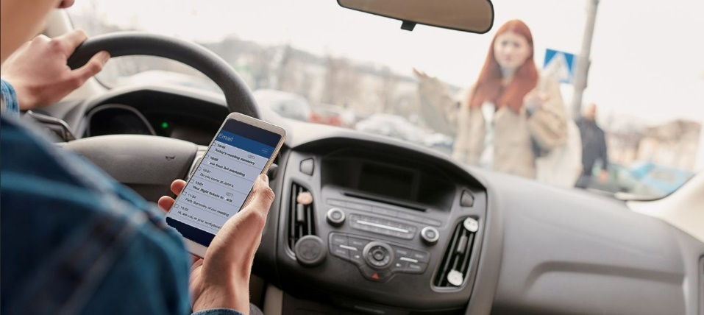
  - OR if the vehicle was being used for personal or unofficial business.

Returning Your Vehicle
At the conclusion of your trip, you need to return the vehicle to the same pickup location.
Clean up after yourself and care for the vehicle. Everyone should clean mud off their shoes before getting in the vehicle. Wipe up spills and remove debris and personal belongings when returning the vehicles. If the vehicle is left extremely dirty, an additional cleaning fee may be charged.
For Evergreen Fleet Motorpool Locations:
- Use the WEX Fuel card to fill the gas tank before returning the vehicle. You can use the Texaco station at 3210 Cooper Point Road to fill up and use the WEX Fuel Card at this location or any other nearby fuel station accepting WEX Fuel Cards. Failure to re-fuel the vehicle will result in a fuel recharging fee.
- Park the vehicle in Lot B in the marked Fleet Motorpool stalls. Take note of the vehicles odometer as you will need to enter this information at the automated key box when returning the keys.
- Turn off headlights and dome lights. Lock all windows and doors.
- Return the keys to the automated key box system located at the Arts Annex overhang (same place your picked up the keys). The reservation remains active until keys are properly returned at the key box.
For DES Tumwater Vans Location (7580 New Market Street, Tumwater):
- Use the WEX Fuel Card to fill the tank before returning.
- Failure to do so will incur a $20 Fueling Charge to your budget.
- Park the vehicle in the same area it was picked up and return the keys to the self-automated key box.
- Use your same evergreen email address and DES Fleet Commander password used to check out the vehicle to login to the automated key box kiosk. Click on "Check In Vehicle". When inserting the keys: First, insert the card holder with the oval cutout facing up, then enter the key and turn it clockwise. You MUST turn the key clockwise to complete the key return and close the key box door. Follow the on-screen prompts.
- You do not need to park the van in same stall, just in the same area.
- If you have the electric cargo van – Please park in the vehicle charging stall and connect to the electric charging station. Lock the doors and return the keys to the automated key box. If the charging stalls are full, park the van with the rest of the vans and return the keys to the automated key box.
For DES Capitol Campus Plaza Garage Rows D5-6 off Washington and 11th.
- If you have a gasoline vehicle, use the WEX Fuel Card to fill the tank before returning.
- Failure to do so will incur a $20 Fueling Charge to your budget.
- Park the vehicle in the same area it was picked up and return the keys to the self-automated key box. Use the same evergreen email address and DES Fleet Commander password used to pick up the vehicle to login to the key box kiosk. Click on "Check In Vehicle." When inserting the keys: First, insert the card holder with the oval cutout facing up, then enter the key and turn it clockwise. You MUST turn the key clockwise to complete the key return and close the key box door.
- You do not need to park the vehicle in the same stall, just in the same area.
- If you have an electric vehicle– Please park in a vehicle charging stall and connect to the electric charging station. Lock the doors and return the keys to the automated key box.
For DES Fones Road Location:
- If you have a gasoline vehicle, use the WEX Fuel Card to fill the tank before returning. The gas station sharing the lot entrance accepts the WEX Fuel cards.
- Failure to do so will incur a $20 Fueling Charge to your budget.
- Park the vehicle in the vehicle returns stalls by the main office or inside the gated parking area during business hours. Lock the doors and return the keys to the office if during business hours. If after hours, put in the key drop box.
- If you have an electric vehicle– Please park in the vehicle charging stall and connect to the electric charging station. Lock the doors and return the keys.

Valid License to Drive and Driving Experience Statement
To promote safe driving practices for the protection of state employees, students, and the citizen and drivers in Washington State, all drivers of state-owned vehicles are required to meet certain driver experiences.
- Possession of a license that is valid under Washington State Law that is current and reflects information consistent with the applicable state licensing department records.
- Two years of experience driving motor vehicles.
- Department of Licensing Driver’s Record is free of violations (described below) that restricts vehicle driving assignments.
- And agree to advise appropriate supervisor/faculty and Evergreen Fleet Motorpool by the next business day if their legal state to drive changes.
Criteria for Restricting a Driver from Driving a State-owned Vehicle
- One or more suspension/revocation of license for reckless driving, hit and run, leaving an accident scene, failure to appear, DUI, or other vehicle-related felony (within the past three years); or
- Multiple traffic offenses (4 moving violations/infractions in 12 months/5 moving violations infractions in 24 months) resulting in a Conditional Status driving record or subsequent suspension/revocation of license; or
- Six or more moving violations within a 12-month period resulting in license suspension.

Full Size Van Safe Driving Practices
Drivers refers to employees, student employees, students, and volunteers operating 12-passenger vans under the direction of a state agency or the college.
Risks Associated with Operating 12-Passenger Full Size Vans
- The National Highway Traffic Safety Administration’s (NHTSA) safety advisory recommends that drivers always insist all occupants wear safety belts. Drivers should verbally remind van passengers that safety belts are to be used until the vehicle is stopped and legally parked. RCW 56.61.688 also requires vehicle occupant safety belt use.
- Drivers should visually check passenger safety belt use, and during transit, stop and legally park the van if made aware of passenger safety belt non-use.
- 12-passenger full size vans have a rollover risk like other light trucks and vans. Prior NHTSA research has shown that 12-passenger vans have a rollover risk that increases dramatically as the number of occupants increases from fewer than five to more than ten. 12-passenger vans require special handling knowledge for safe operation of the vehicle.
- The weight of the van, particularly when fully occupied, causes the center of gravity to shift rearward and upward increasing the likelihood of rollover.
- The shift in the center of gravity will also increase the potential for loss of control in a panic maneuver.
- The weight of the van when fully occupied requires additional stopping distance, an especially crucial factor in rain, fog, or other difficult driving situations caused by weather conditions.
- The width of the van allows for less lane room and the length of the van increases distance needed for making turns, changing lanes, and braking.
- General maintenance of the vehicle, including proper tire pressure is important to safety, and can be referenced in the vehicle’s owner’s manual.
Basic Driving Practices for Safe Van Operation
- Driving at posted or lower speeds.
- Adjusting to lower speeds for special conditions such as rain, snow, fog, wind, and other conditions affecting visibility, stopping distance or general safe handling of the vehicle.
- Minimizing potential driver distraction by using cell phone or other devices on when the van is safety stopped and parked or asking passengers to assist with calls for emergencies.
- Properly loading passengers, equipment, and never placing equipment/luggage on the top of passenger vans.
- Minimizing driver fatigue on long trips by one or more of the following: driving rested, taking appropriate breaks, or sharing driving with other authorized drivers. Follow agency policies on travel time restrictions.
- No driving while under the influence of intoxicating beverages, drugs, or any other impairing substances as advised by health professionals.

Policy Acknowledgement and Acceptance
By clicking submit, I acknowledge that on the date submitted (which will be digitally stored and recorded) I reviewed, at a minimum, the Driver Responsibilities and standards in the Evergreen Motorpool Policy, Evergreen Travel Policy, the Evergreen Fleet Motorpool Policy and Operations Manual, and the WA DES Enterprise-Wide Transportation Policy and agree to comply with the requirements established in the policies and procedures. I will immediately inform my supervisor/faculty member and Evergreen Fleet Motorpool should my license be revoked or suspended for any reason. I understand that any behavior not adhering to the policies may result in disciplinary action by my agency per RCW 43.19.635. I have read and understand potential risks involved while operating 12-passenger full size vans and understand that a 15-passenger van should never be used to transport passengers. I am aware handling characteristics of 12 passenger full size vans may change, especially when fully loaded. I understand extra caution is required when operating 12-passenger full size vans, included reduced speeds. I understand van driver/passenger safety belt use is required and will remind passengers and visually check for belt use and will stop and legally park the van if made aware of passenger non-use during transit.
By clicking submit, I acknowledge that on the date submitted (which will be digitally stored and recorded) that I have a driver’s license that is valid under Washington State law that is current and reflects information consistent with the applicable state licensing department records; I have at least two years of experience driving motor vehicles; my Department of Licensing Driver’s Record is free of all the excluding driving criteria listed for driving a college/state-owned vehicle; as a condition of driving, I agree to inform my supervisor/faculty member by the next business day if my status to legally drive a state-owned vehicle changes.

Drivers Name:
Drivers Evergreen A#:
Drivers Signature:
Date: Driver’s Department/Program:
Driver’s License Expiration Date:

